Richard Rennehan
DBAS3019/Business Data Modelling
10/5/2018
Bike MS 2018 Report
Contents
Part 1: What? 2
Part 2: Why? 3
Company Background 3
Identifying the Business Processes 4
Stakeholder Analysis 6
Part 3: Data Sources 9
Part 4: Data Visualizations 12
References 18

Part 1: What?

The mission of Bike MS Events is to gather money for multiple sclerosis research. Using donation money, the National Multiple Sclerosis Society can perform valuable research to discover treatments for multiple sclerosis and save lives.

Bike MS is interested in finding out how to increase participant acquisition and maximize donation amounts. For the purpose of this report, we will answer their questions including:
- What Industries have had the strongest involvement in Bike MS in the last five years?
- What is the common denominator for the top performing teams? (Is it industry, culture, executive involvement, connection to MS, other?)
- Once someone is registered, what tactics and behaviors drive fundraising, and at what times leading up to the event?

To begin, this report will give background to Bike MS and list its business processes and stakeholders. Then, the data sources and cleaning methods will be identified before showing visualizations revealing our results.

Part 2: Why?

Company Background

According to Teradata (n.d.), “Bike MS is the National MS Society’s largest fundraising campaign, engaging over 70,000 participants to raise $68 million in over 75 rides across the country. It is the largest charity cycling series in the United States.”

The Teradata site also states the following about their current state in the industry:
The events are team-focused, with teams responsible for 87% of fundraising. Because of participant demographics (mostly male, middle age, higher income earners), we know that Bike MS is an ideal corporate event and that corporate teams of 10 or more cyclists are seven times more valuable than any other kind of team. Companies with a large professional employee base, especially those with a corporate culture of health and wellness – regardless of industry – are key prospects.

Over the years, the charity cycling space has become very crowded with many events vying for the same audience. Bike MS participation and revenue have seen a steady decline since our peak in 2012. While retention is relatively high – over 50% – there are not enough new participants joining the series to reverse the damage caused by attrition. We must increase new participant acquisition. (Teradata, n.d.).

Identifying the Business Processes

Here’s the list of processes required to fulfill the goal of donations for the event:

Procure
- Plan and organize event.
- Gather sponsors.
- Get volunteers to help manage event.
- Grab attention of the public about the event. Gather participants.
Produce
- Management and volunteers ensure the event runs smoothly.
- Participants organize into teams.
- Participants and teams solicit and collect donations.
Fulfill
- Gather all donations together and send off to the National Multiple Sclerosis Society.

Figure 1: The Business Process Flow. Bike MS is currently focusing on how to attract more participants and maximize donations.

Stakeholder Analysis

Here is a list of stakeholders that are integral to the success of the event

- The National Multiple Sclerosis Society
- Event Sponsors
- Volunteers
- Participants
- The Public

We can group each into one of 4 quadrants. Each quadrant is based on the amount of power they have over the event’s success and the amount of interest they have in the development process of the event.

High Power; Low Interest
High Power; High Interest
Low Power; Low Interest
Low Power; High Interest
Power
Interest
- National Multiple Sclerosis Society
- Event sponsors

- Participants
- The public

- Volunteers

Stakeholders in the upper right are the difference between the event moving forward or not, so they will need to be managed closely and persuaded to support the event. Stakeholders in the upper left only care about the impact of the event so they will need to be kept satisfied to ensure success. Stakeholders in the bottom right control the event or are affected by the event so they will need to be kept informed about developments.

From this, we can make a communication strategy chart for each stakeholder or group:

Stakeholder/Group | Frequency of Communication | Communication Method/Strategy
National Multiple Sclerosis Society | Daily/Weekly | Face-to-face and digital. Exchange information on event results and developments. Focus on agreements.
Event Sponsors | Daily/Weekly | Focus on winning sponsors over. Use persuasion techniques. Provide plenty of documentation about the event so they do not fear the unknown.
Participants | Weekly | Digital communication. Send emails describing event updates and important information. Avoid going too deep into event proceedings, as they have a lower level of interest than volunteers.
Volunteers | Daily/Weekly | Provide plenty of information about the proceedings of the event. Ensure volunteers are knowledgeable about what their role is.
Public | Daily/Weekly | Focus on building interest with advertising campaign. Goal is to convert to either a participant or volunteer.

Part 3: Data Sources

The data used comes from the Teradata 2018 Data Challenge site. Spreadsheets are provided for 2013-2017 events, 2013-2017 participants, and for donations. The donation spreadsheets are stored as separate files for each year due to Excel’s max row limitation per file.

Using Tableau, we union-ed all donation sheets into one 2013-2017 donations file. Then, we did inner joins with the other datasets. Tableau maintains a live link to files and includes a data cleaner, so high quality data is ensured throughout the analyzation process.

The following ERD describes the relations between each table:
Figure 2: ERD describing links and relations

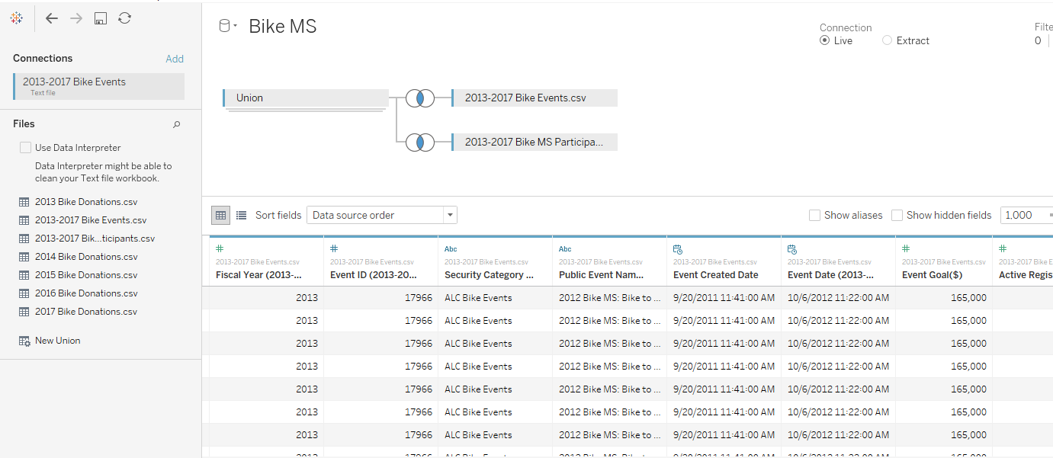
Figure 3: The setup in Tableau. Data is ready to be analyzed

Part 4: Data Visualizations

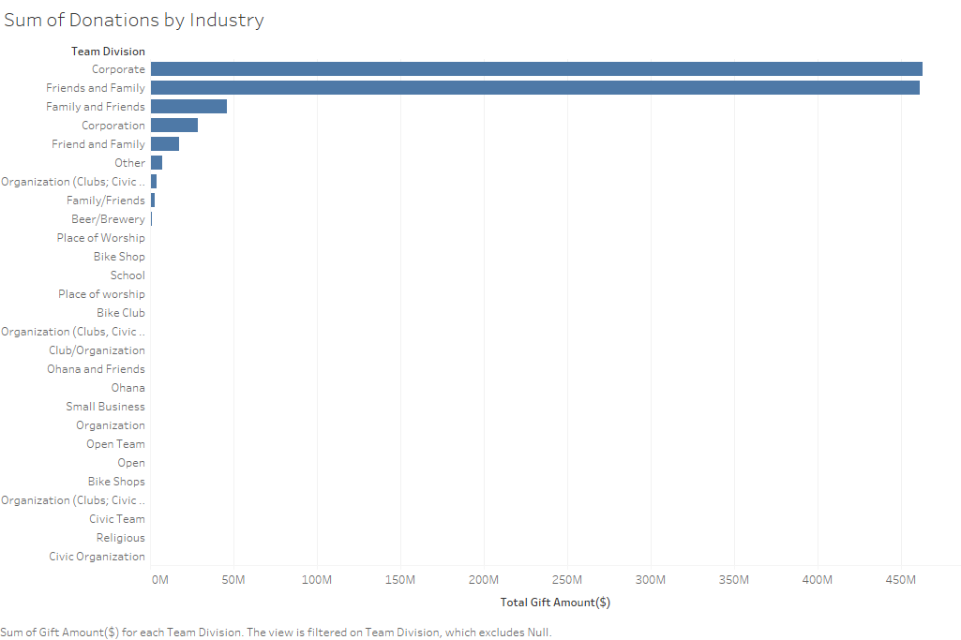
The above visualization shows the sum of donations by the division of the team. As shown above, corporate teams lead alongside friends and family teams. The closest contender is organizations. With this visualization, we can conclude that corporate teams are the greatest concern, and that there is wide potential for more friends and family groups.

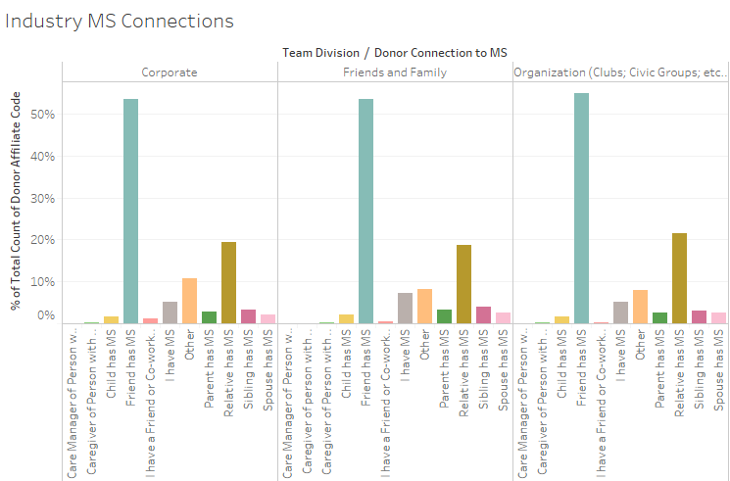
The above visualization demonstrates the relationship between the top team division categories when it comes to MS Connections. Each participant on a team was asked if they have a connection to MS. Any null values were excluded.

Each division shares similar experiences to MS in the lives of each participant. There is a strong link between people participating because their friend has MS among all three, at greater than 50% each.. The second most common answer amongst the three is a relative having MS, averaging around 20% of each division’s respondents.

Through this visualization, we can conclude that marketing to those who have suffered a friend or relative being diagnosed with MS would be effective.
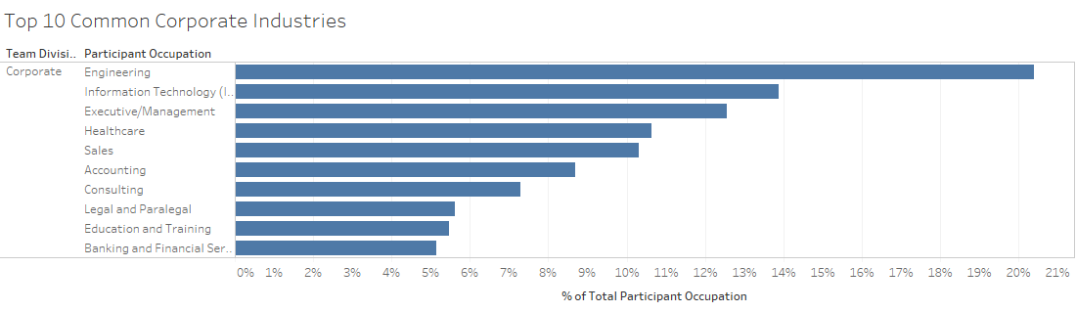
The above visualization demonstrates the top 10 industries for corporate teams. This was done by gathering the occupations of participants who belonged to a corporate team.

More than 20% of the selected respondents answered engineering as their occupation. This is a big jump over the next largest category: IT, at nearly 14% of the respondents.

This visualization reveals that marketing towards engineering companies would be effective to gathering more participants and donations.

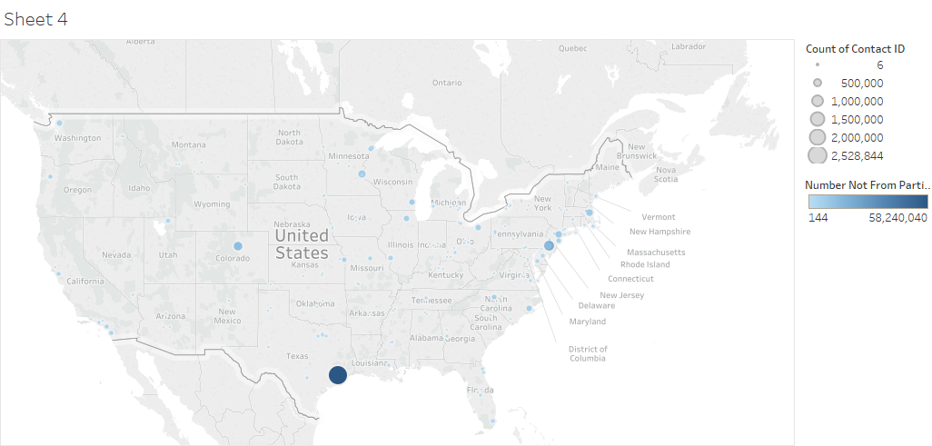
Zip Codes by # of Participants and Total Donation Amount Not from Participants
The above visualization shows zip codes of participants among the United States based on the total number of participants in the area and the total donation amount.

South-eastern Texas is the greatest region by number of participants and total donation amount. The next area of notability is the New Jersey area, where there is a surge in interest. There is also interest from Los Angeles and other populated areas from California. There is also interest from all states just south of Ontario. Also of interest, there is a big spike from Denver, Colorado.

This visualization shows that these areas are proven to be the best to market towards to guarantee success.

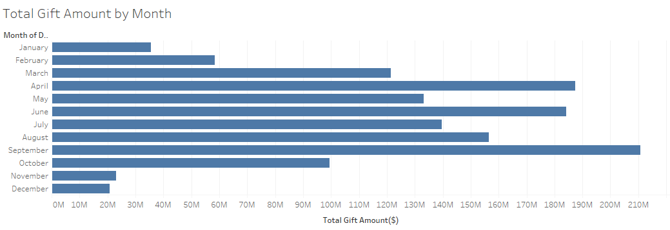
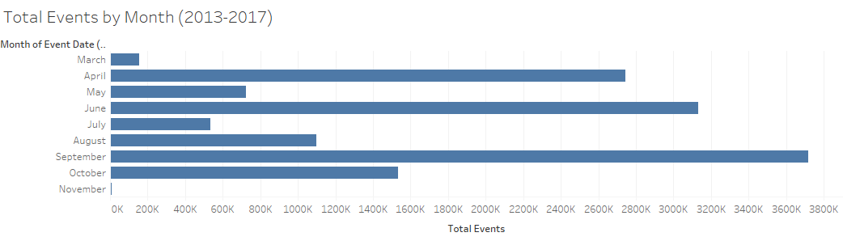
The first of the above visualizations reveals total donation amounts for each of the 12 months between 2013 and 2017. It takes the month of every donation and the gift amount of each and sums it up.

The months with the greatest interest are April, June, and September. As demonstrated in the second visualization, these are also the months with the greatest number of events.

More interestingly, the months of March, July, and August have a much larger proportion of donation money compared to number of events. This demonstrates a trend where participants like to get a head start with donation collection a month or two before their event.

As a result, an effective strategy is to get participants interested a few months before the event and gradually build up interest as the event draws near.

References

Teradata. (n.d.). 2018 Data Challenge. Retrieved from https://www.teradatauniversitynetwork.com/Community/Student-Competitions/2018/2018-Data-Challenge

